

TRAVEL REQUEST & EXPENSE
MANAGEMENT SYSTEM
QUICK USER GUIDE
Application Platform: RefexOne – Travel Management
Version 1.0 | 26 August 2026
Private and Confidential – Internal Use Only

Introduction
This guide explains how to use the Travel Management application in RefexOne to raise a travel request, request a travel advance, and submit your travel expense claim. It covers the three modules on the dashboard — Travel Booking, Travel Advance, and Travel Expense — with the steps for each.

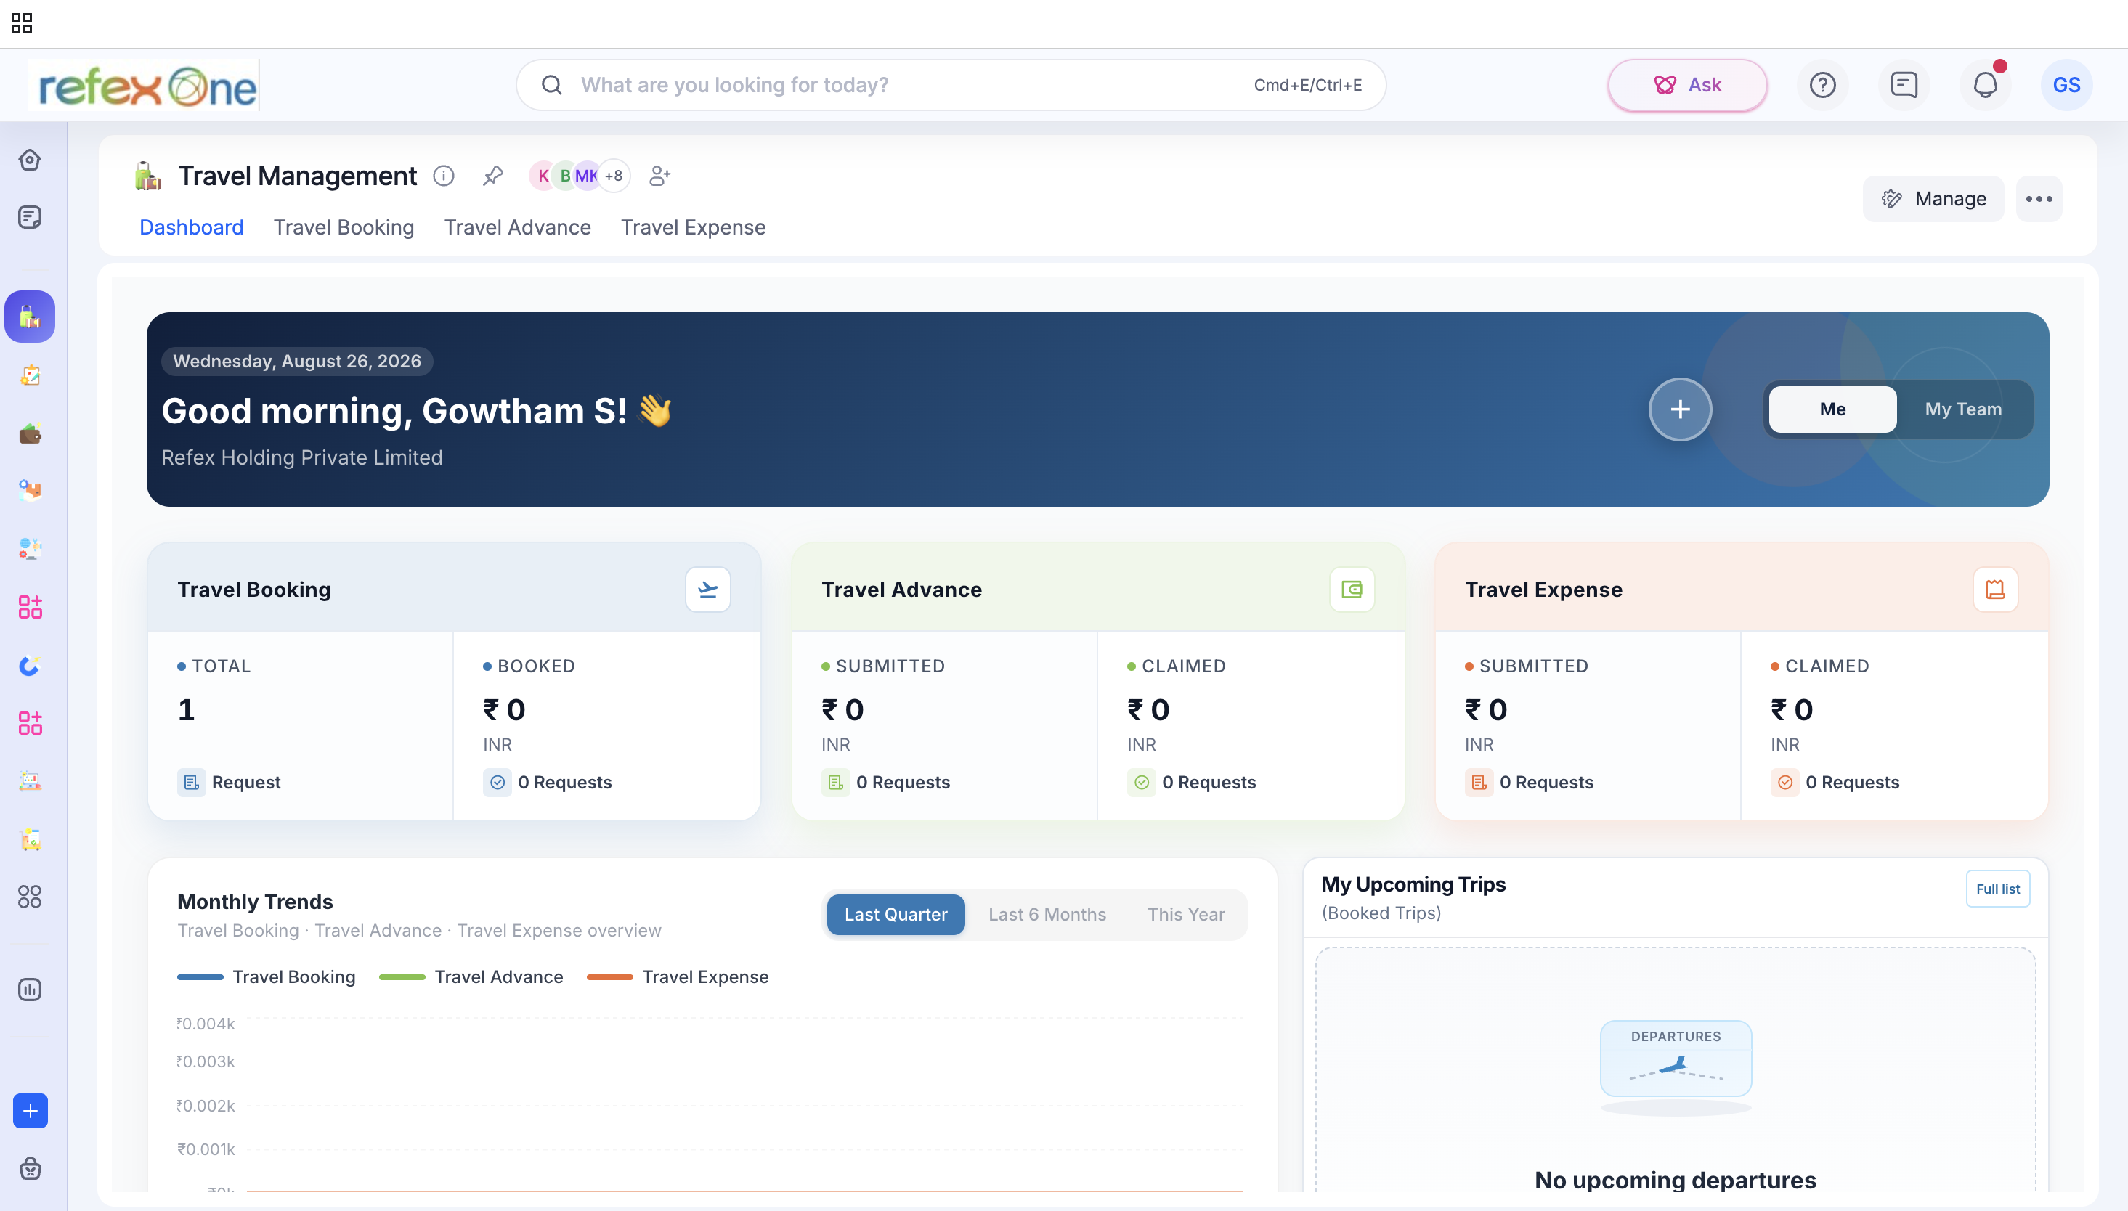
Figure 1: The Travel Management Dashboard. Use the tabs at the top — Dashboard, Travel Booking, Travel Advance, Travel Expense — or the blue + button to start a new request.


Figure 2: Clicking + opens a quick-create menu to start a Travel Booking, Travel Advance or Travel Expense request.

Module 1: Travel Booking (Travel Request)
Use this module to request and book your business travel.

How to Create and Submit a Travel Request
- On the Dashboard, click + and select Travel Booking (or open the Travel Booking tab).
- Select your Travel Purpose and Travel Mode (Air / Bus / Train).
- Choose Yes if you want the Travel Desk to book your ticket, or No if not.

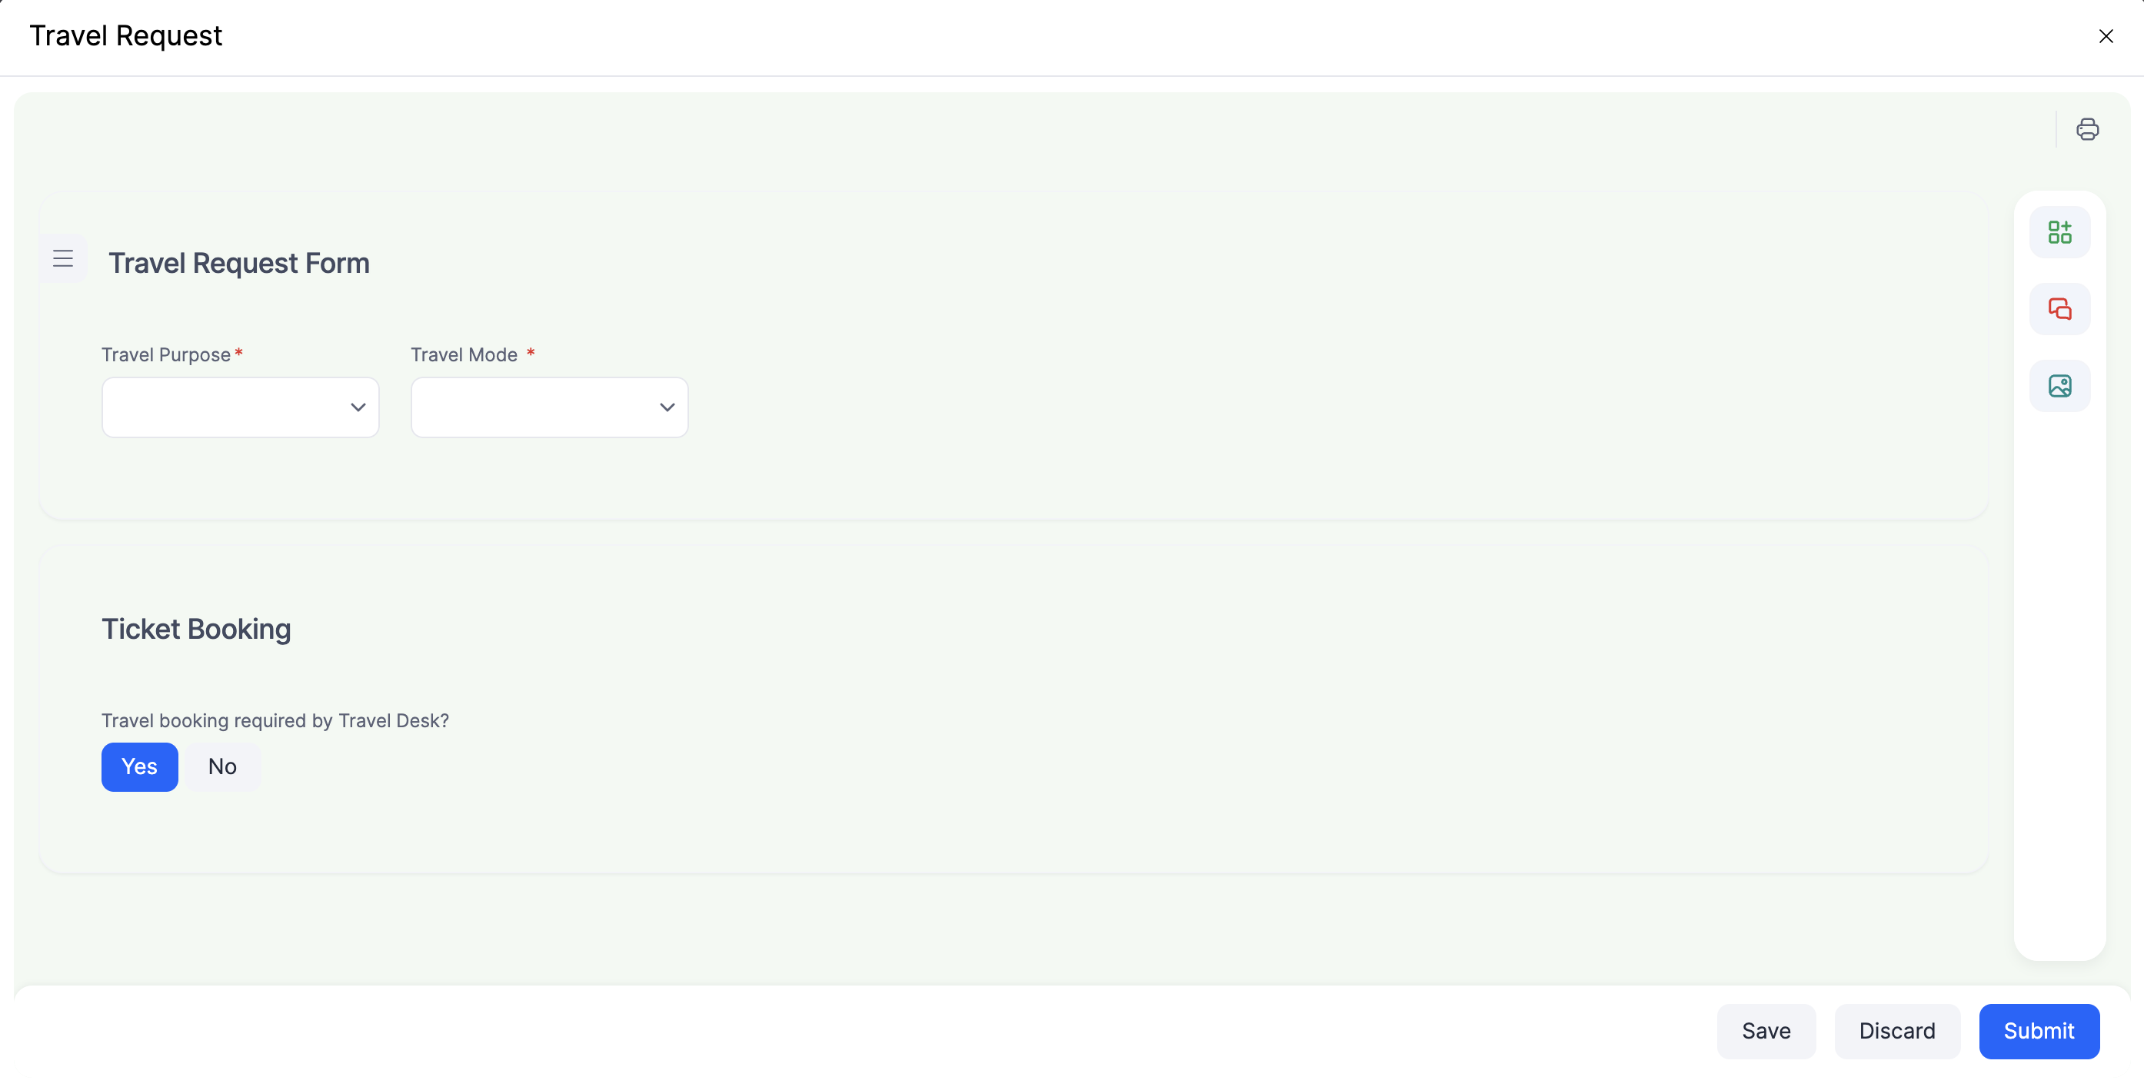
Figure 3: Travel Request Form – Travel Purpose, Travel Mode and the Ticket Booking option.
- If Travel Desk booking is needed, search for your flight: enter From, To, date(s) and Class, then click SEARCH.
- Pick the flight you want and click Select. (One Way, Round Trip and Multi-city are all supported.)

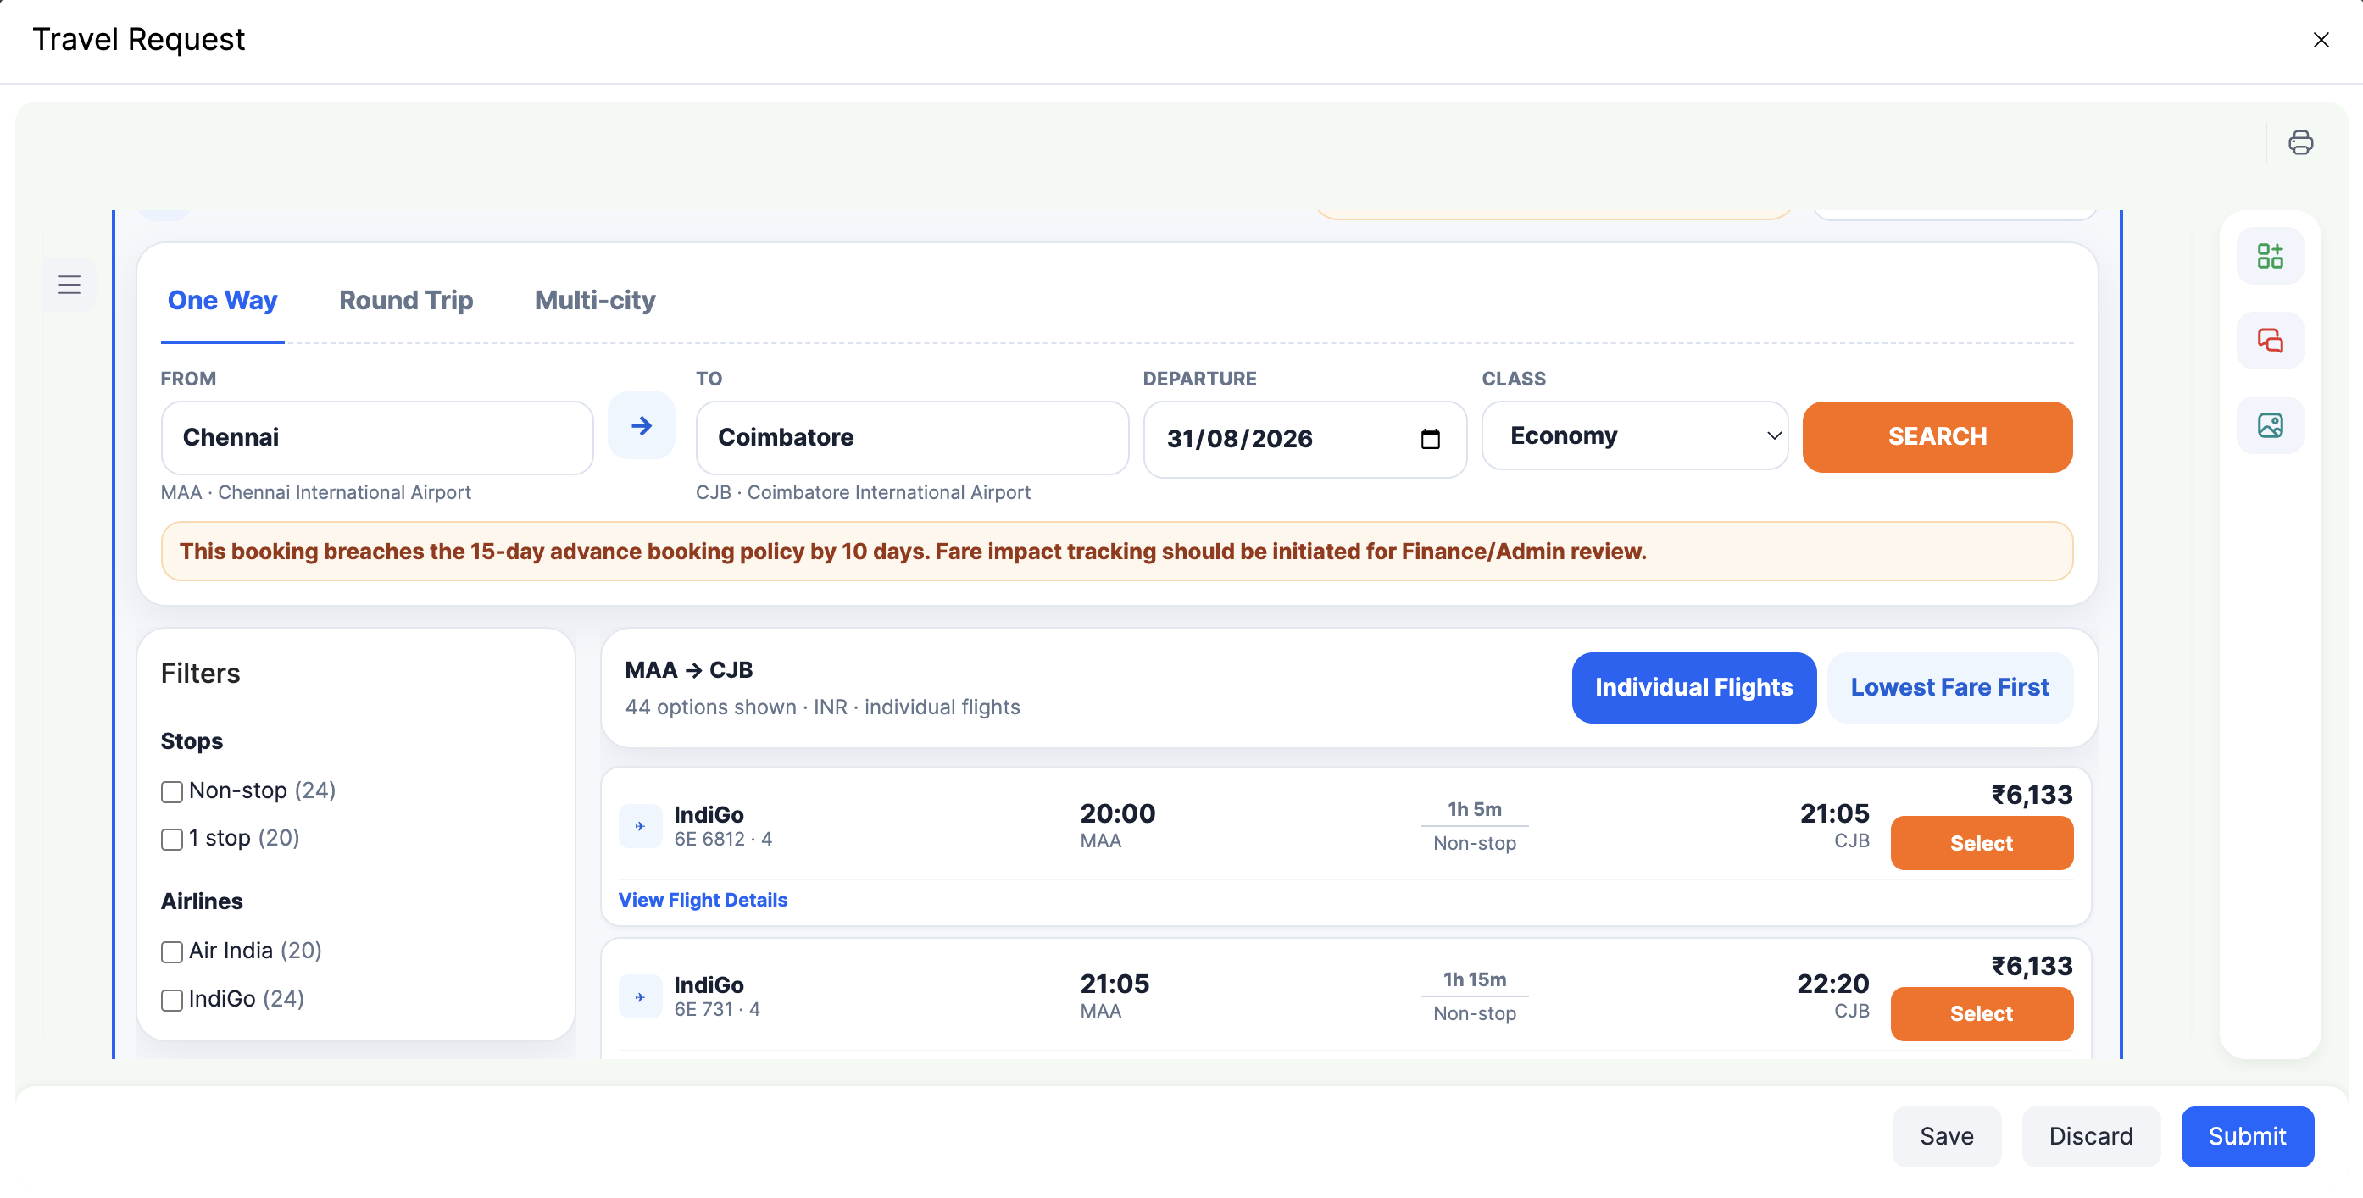
Figure 4: Searching and selecting a flight for the trip.
- Click Submit to send the request for approval (or Save to keep it as a draft).

What Happens Next
- Your Manager approves the request (cost approval).
- The Travel Desk shares booking options — review and confirm your preferred option.
- The Travel Desk confirms the booking.
- Upload your Boarding Pass against the request once you have it, and check the details are correct.
- Need to change your travel plan? Open the request and use Modify Travel — the change goes back to the Travel Desk (and Management, if needed) for approval.

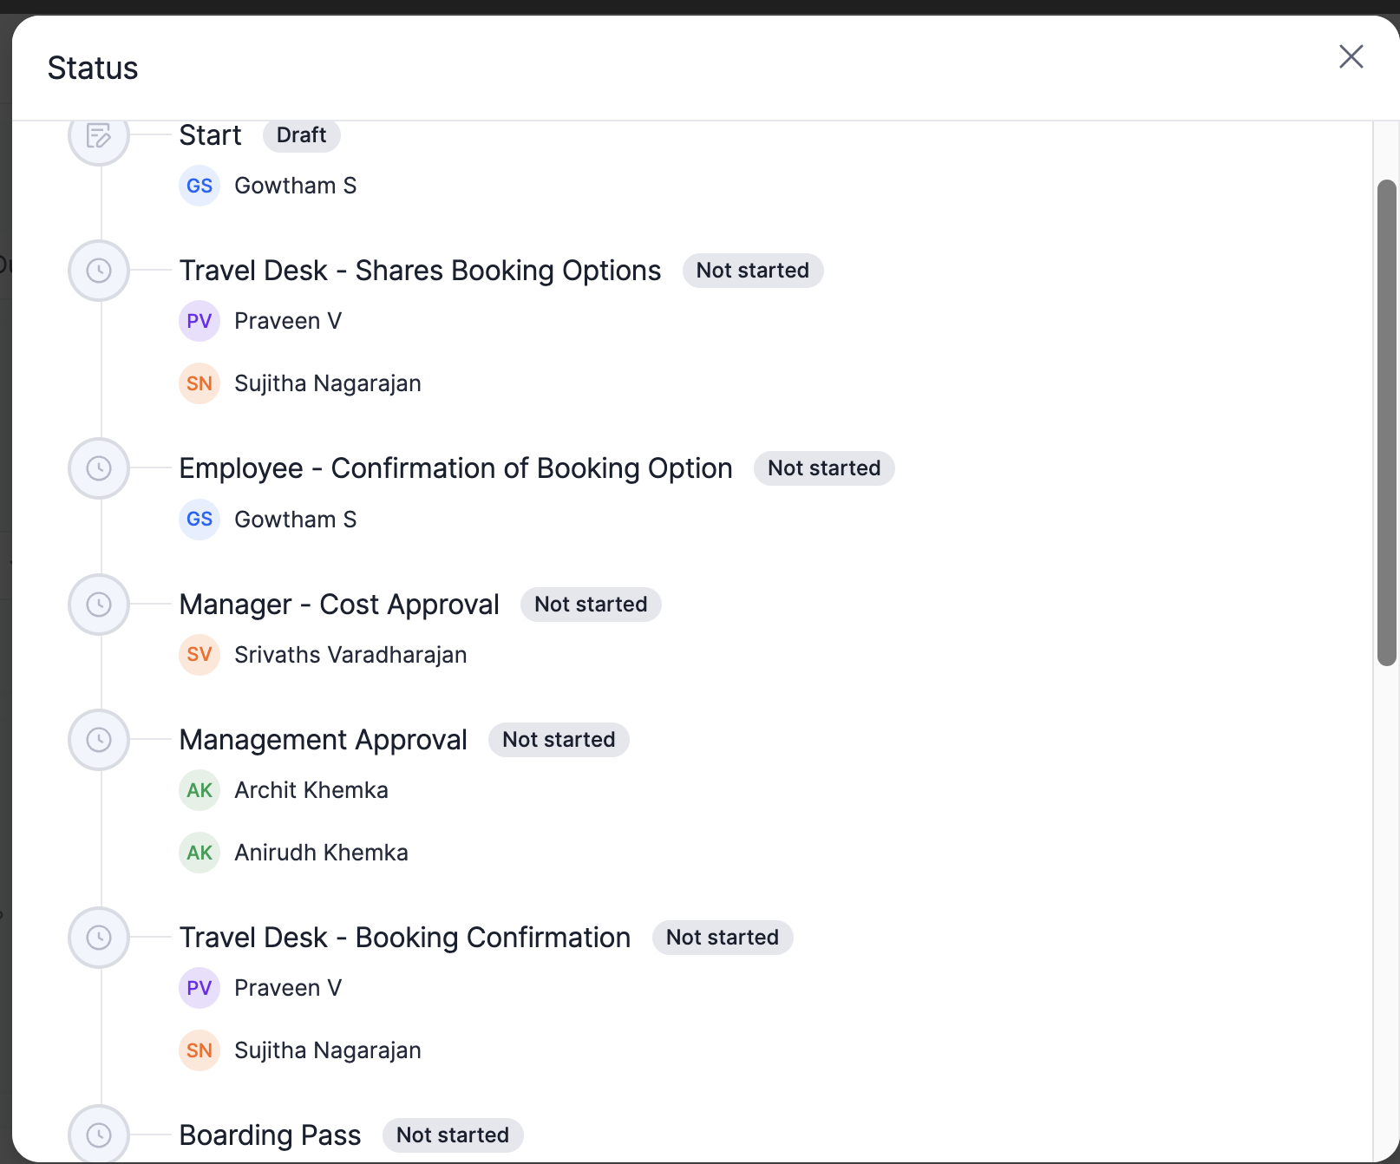
Figure 5: You can track every stage of your request — from Manager approval to Boarding Pass — in the Status view.

Module 2: Travel Advance
Use this module to request funds in advance for an approved trip.

How to Create and Submit an Advance Request
- Click + and select Travel Advance (or open the Travel Advance tab). Your Travel Request must already be approved.
- Use Link to travel to search for and select your approved Travel Request.

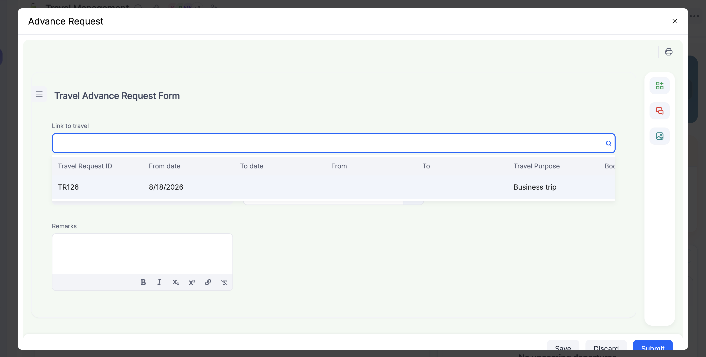
Figure 6: Search for your approved trip and link it to the advance request.
- Enter the Advance amount you need (in INR), and add a Remarks note if useful.

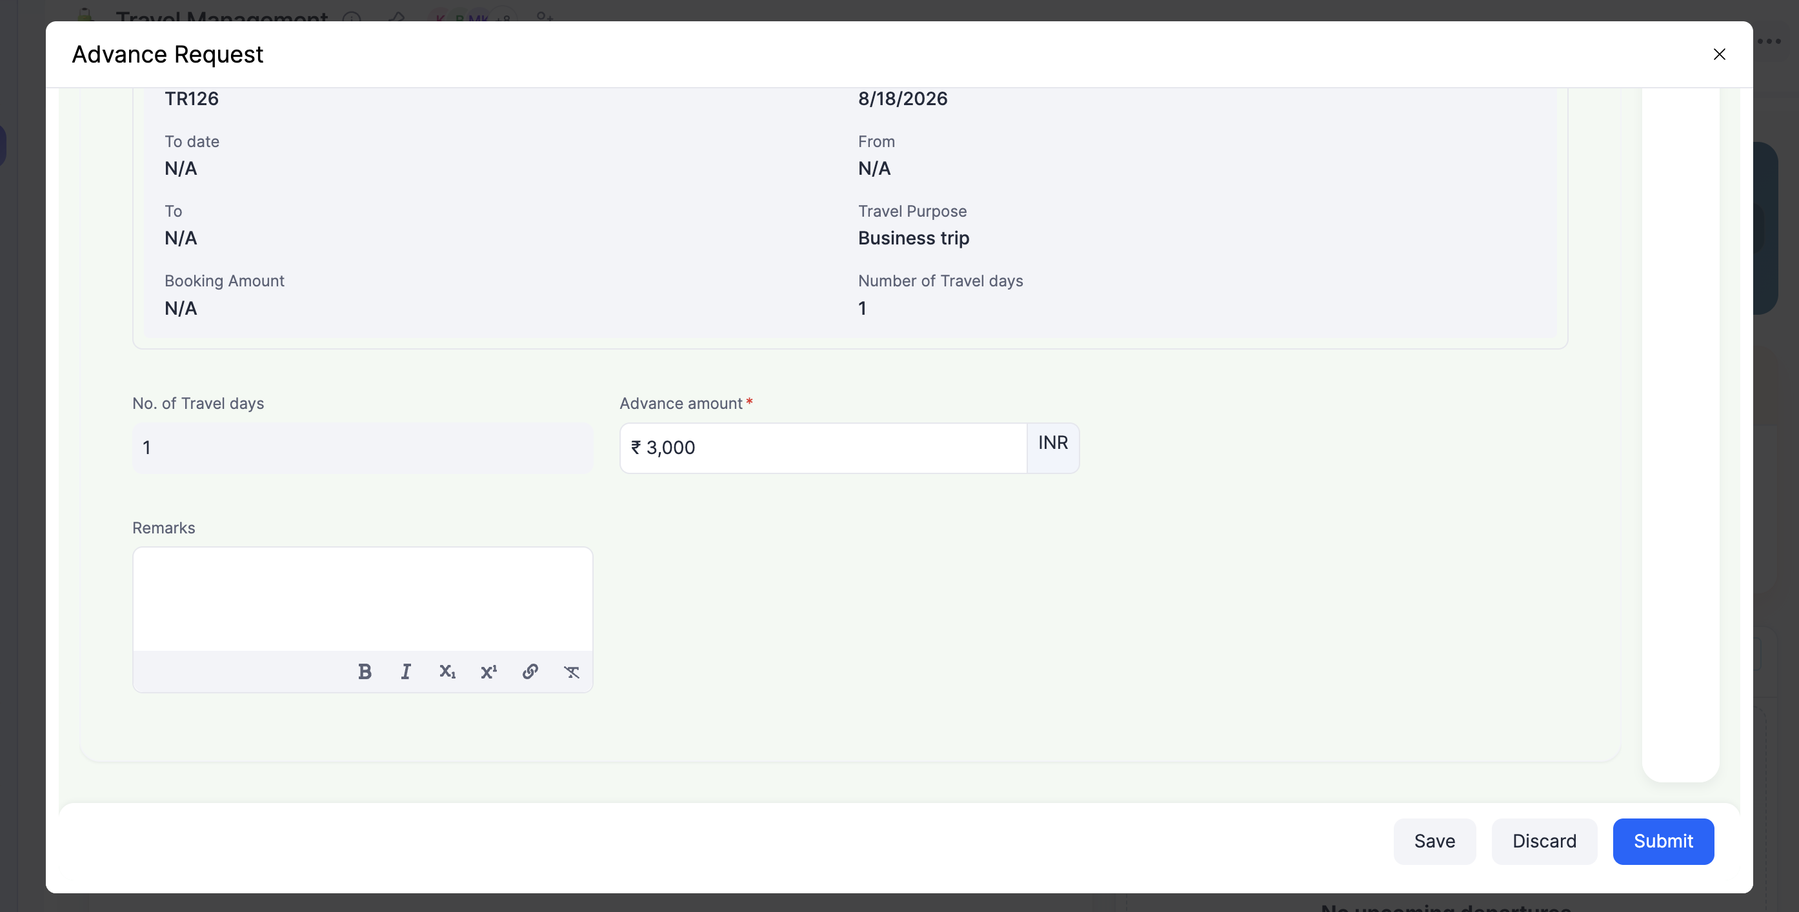
Figure 7: Trip details are auto-filled — enter only the Advance amount and, optionally, Remarks.
- Click Submit.

What Happens Next
Employee → Manager → Finance → Advance Release. Your Manager approves the request, Finance validates and approves the amount, and the advance is released to you.

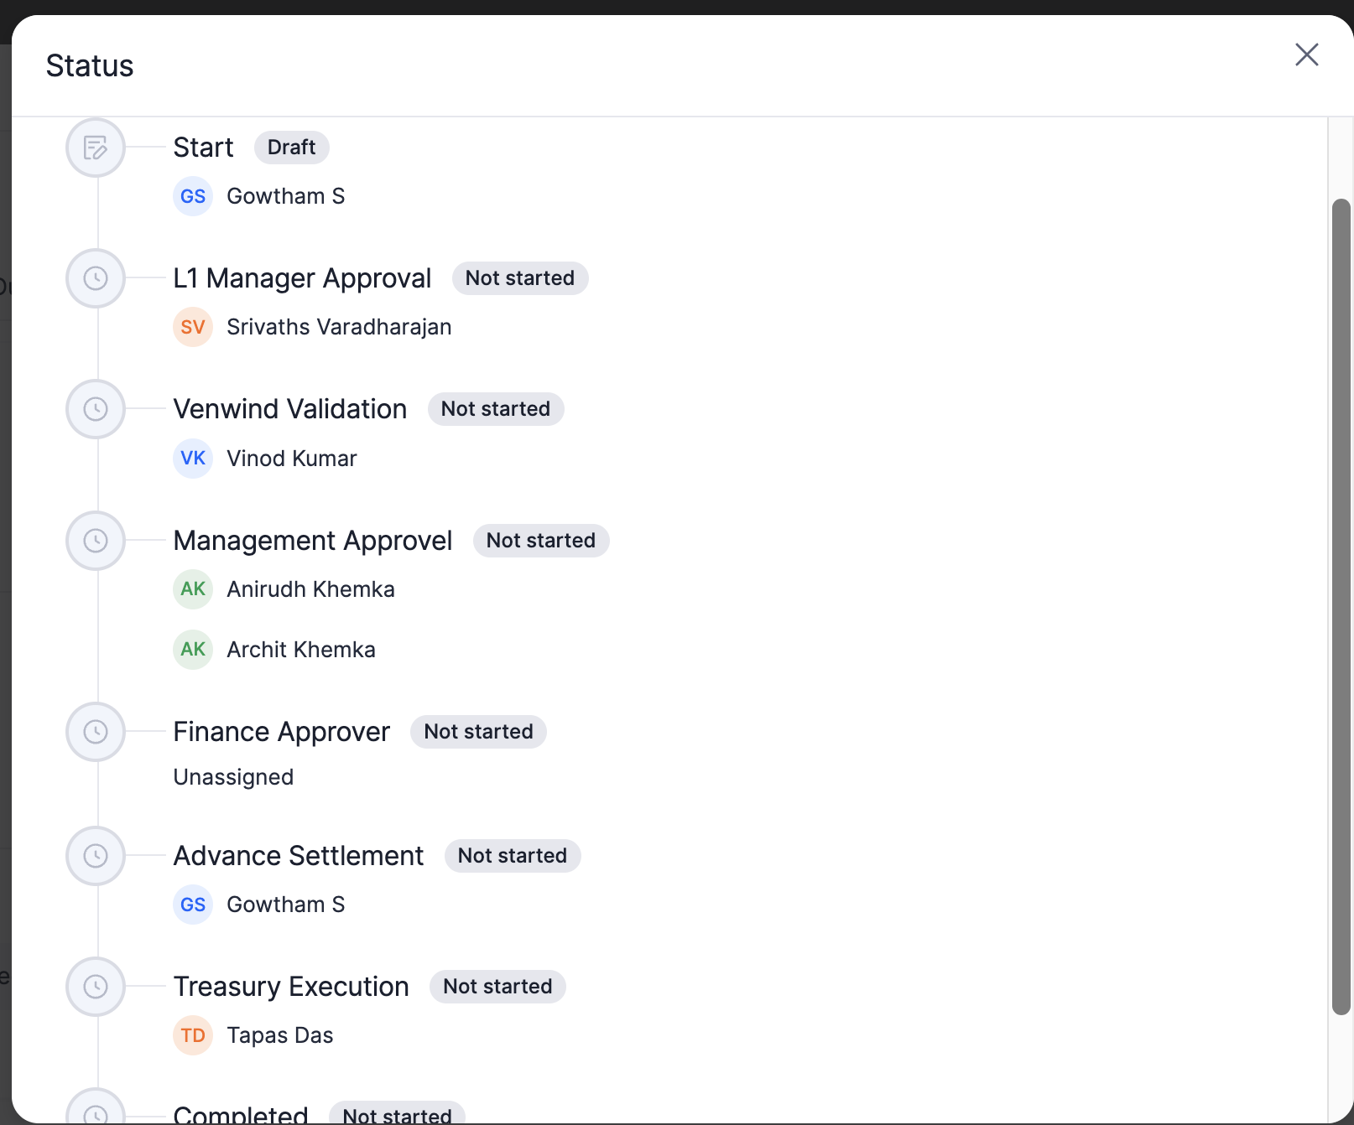
Figure 8: Track your advance request through Manager approval, Finance approval and release, in the Status view.

Module 3: Travel Expense
Use this module after your trip to claim reimbursement for your expenses.

How to Create and Submit an Expense Claim
- Click + and select Travel Expense (or open the Travel Expense tab).
- Select one or more Expense Type(s) — Food, Accomodation, Travel Ticket, Local Conveyance — set the Expense Date, and link the Travel Request if applicable.

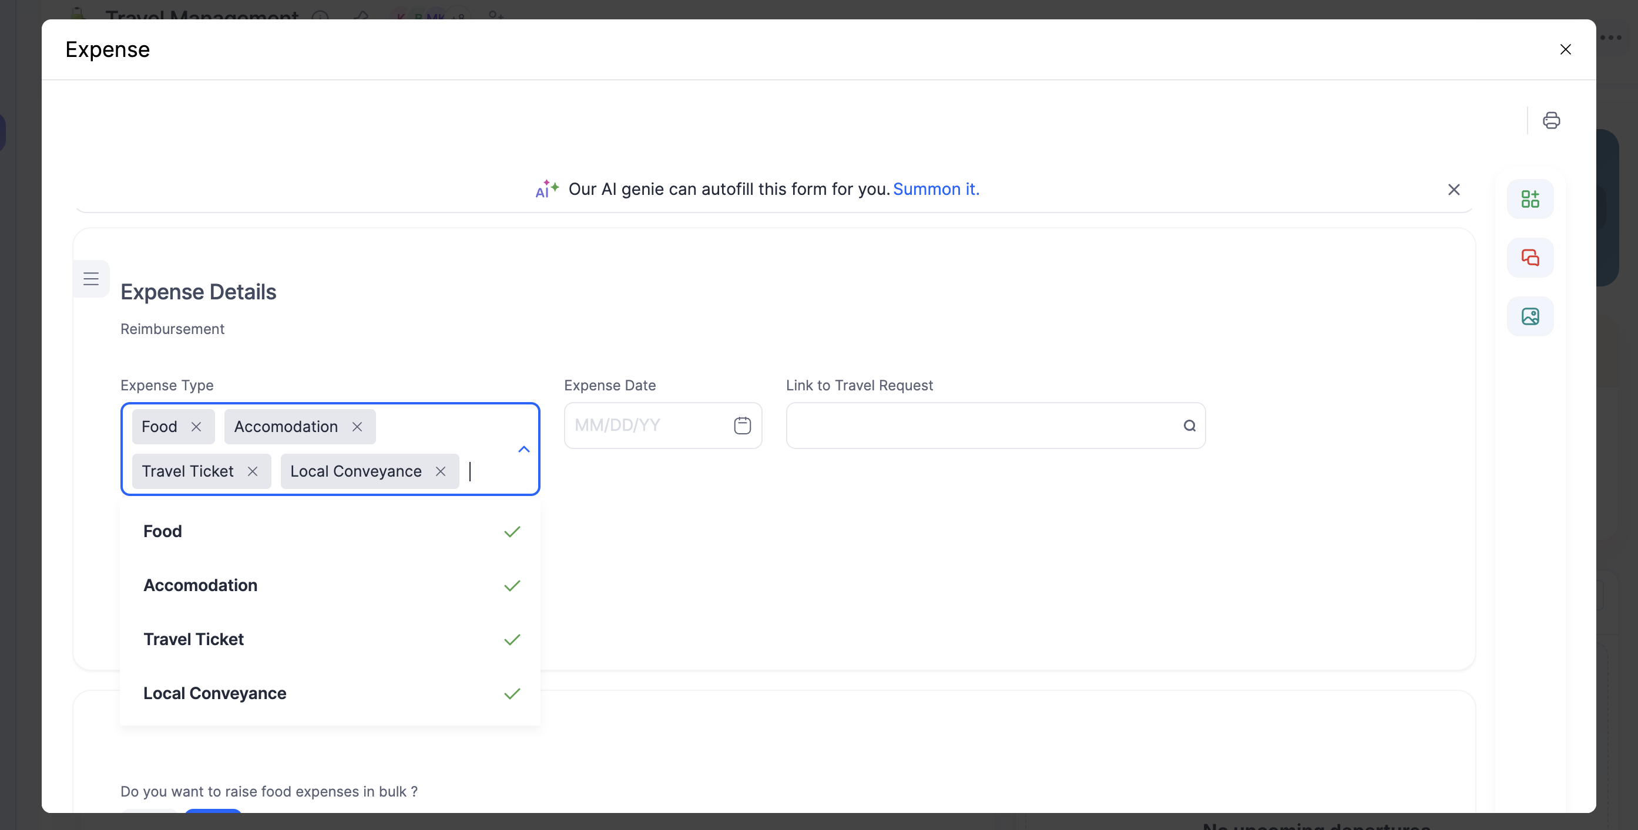
Figure 9: Select your expense category, date, and (if applicable) the related Travel Request.
- Upload your bill/receipt for each expense. If you have several bills of the same category, choose Yes under "raise in bulk" and upload one consolidated PDF.

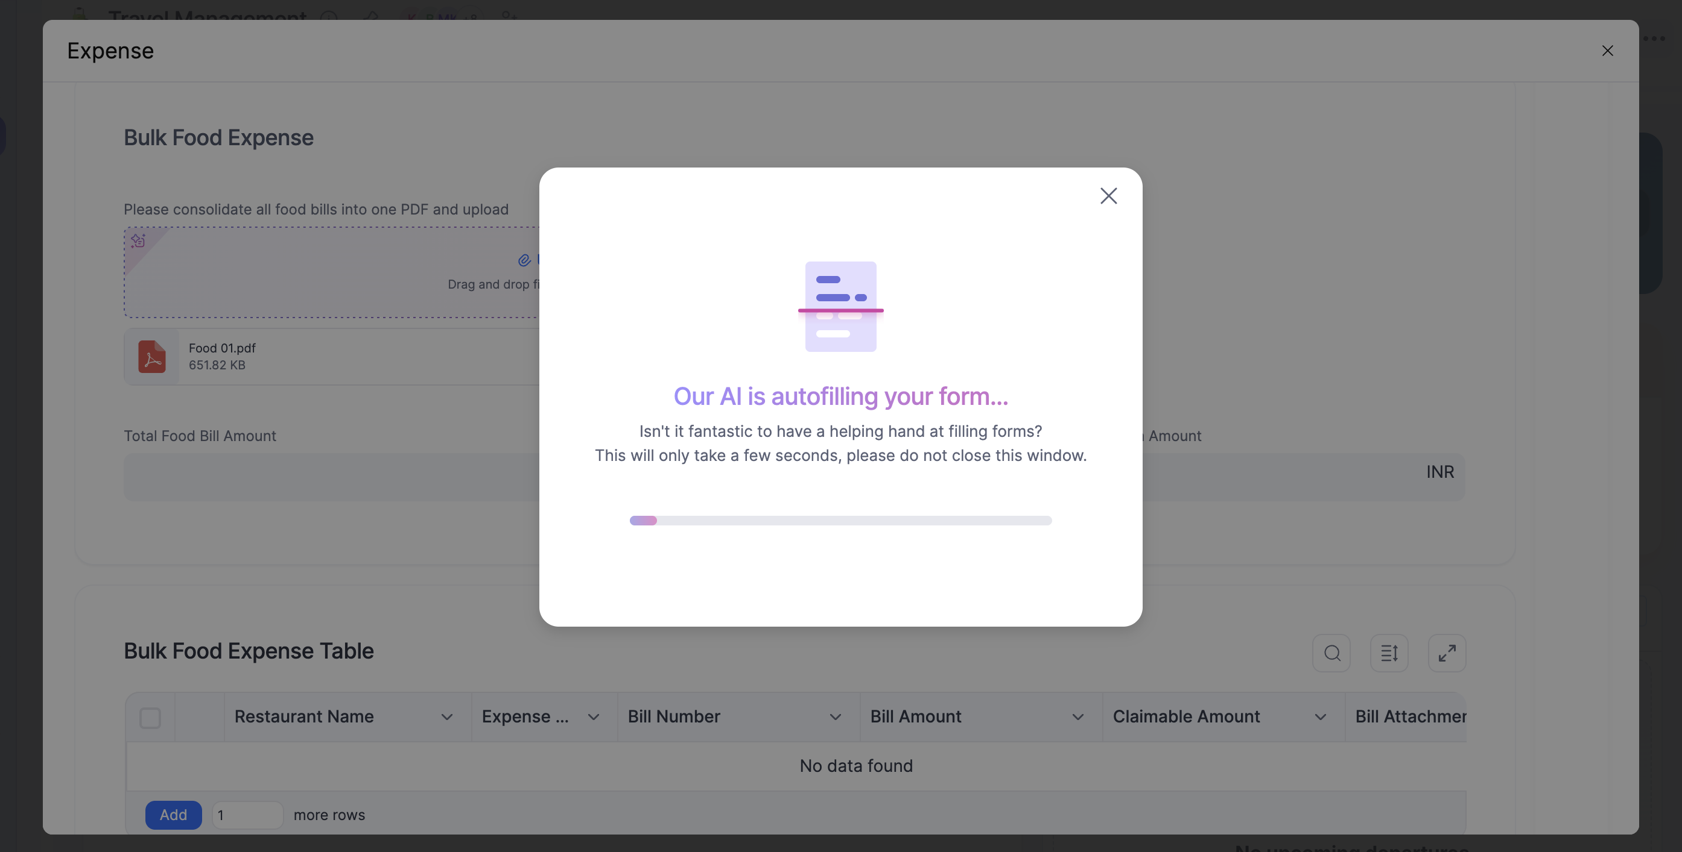
Figure 10: Upload the bill — the system reads (OCR) the details into the table automatically.
- Wait for the system to auto-fill the details from your bill (OCR), then carefully check every value against the original bill and correct anything wrong.
- If the bill is in a foreign currency (or even INR), click Load Data to confirm the amount in INR.
- Click Submit once all entries and bills are correct.
IMPORTANT
Always verify OCR data before submitting. OCR is not 100% accurate — compare every extracted amount with the actual bill.

What Happens Next
Employee → Manager Approval → Finance Validation → Final Settlement.
Finance checks your bills and amounts, then settles the claim against any advance you already received:
Situation | Result
Advance ₹10,000 vs. Approved Expenses ₹8,000 | You return ₹2,000 to Finance.
Advance ₹10,000 vs. Approved Expenses ₹12,000 | Finance pays you the extra ₹2,000.

Track your claim's progress (Manager approval → Finance validation → Settlement) any time from its Status view.

